CIS 4911 – Senior Project
Tractouch's iBLESS
User Manual

Team Members: Luis Miguel Carrillo
Mentor: Jaime Borras
04/26/2015
COPYRIGHTS AND TRADEMARK INFORMATION

This work is entirely done by Luis Miguel Carrillo unless written otherwise.

Create Table

Inside the default welcome screen, click on “Create Hierarchy”

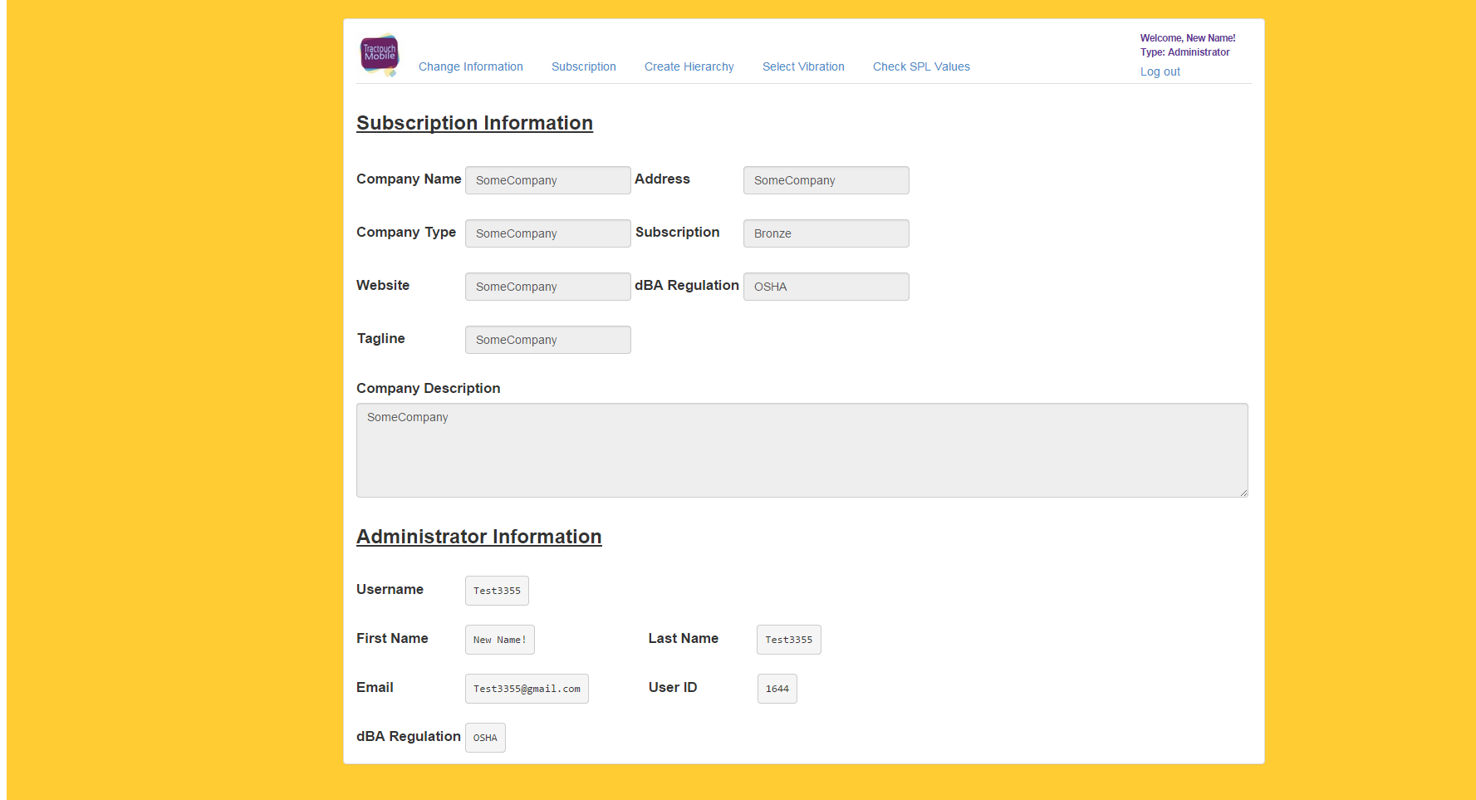
After clicking, the following screen is displayed.

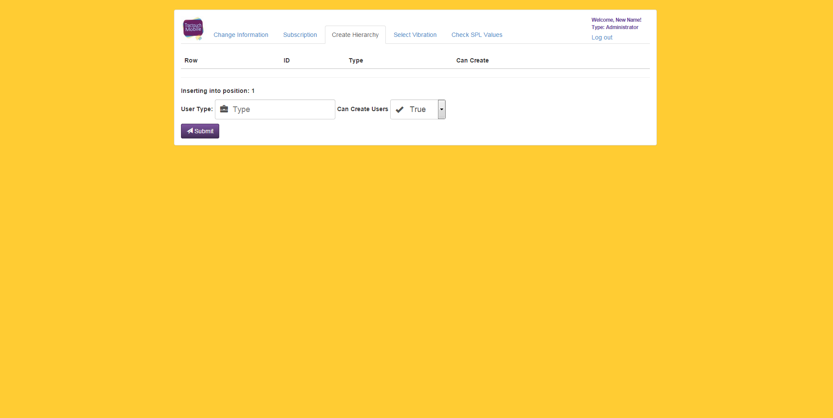
The user adds a new user type, and sets whether users of that type will be allowed to create new users as if acting as the subscriber.

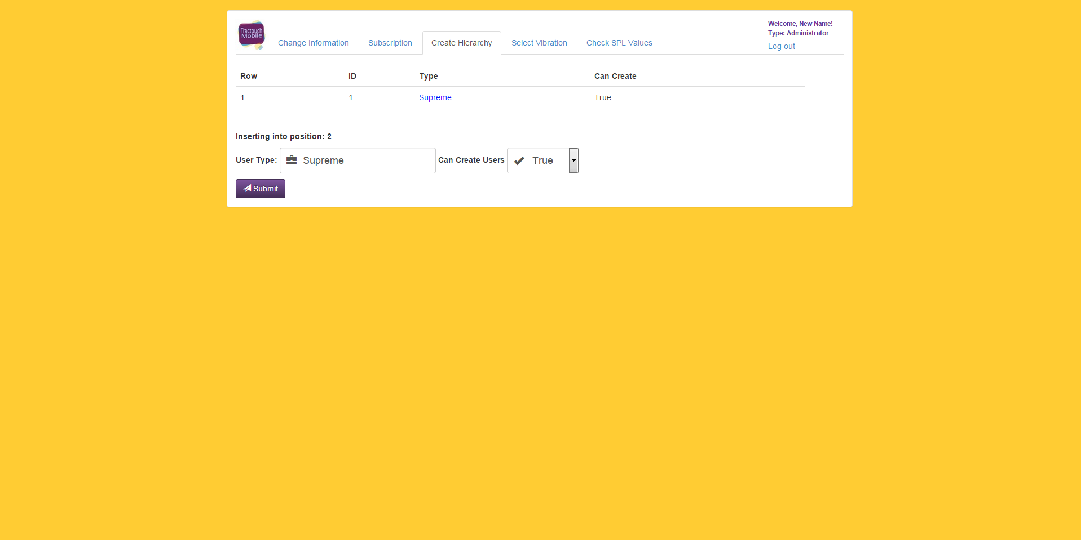
Delete User Type

The user clicks on the blue label in order to display available actions with that specific user type.


Click on “Delete” in order to delete that type.

Modify Type

The user clicks on the blue label to display the actions, and clicks on “Modify Info”.

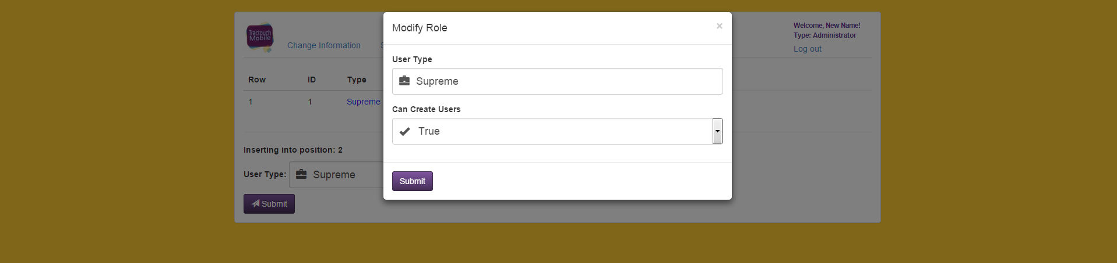
Change the information as wanted, and click submit.
Add SPL Range

Click on “Select Vibration” on the navigation bar. The following screen will be displayed.


Set low dB to the range's minimum, and high dB to the range's maximum. Also, set the vibration pattern to the possible selections by clicking on the combo box. Finally, click submit to add the new range.

Delete SPL Range

Click on the blue label to display all related actions, and choose “Delete”.


Modify SPL Range

Click on the blue label to display all related actions, and choose “Modify Info”.

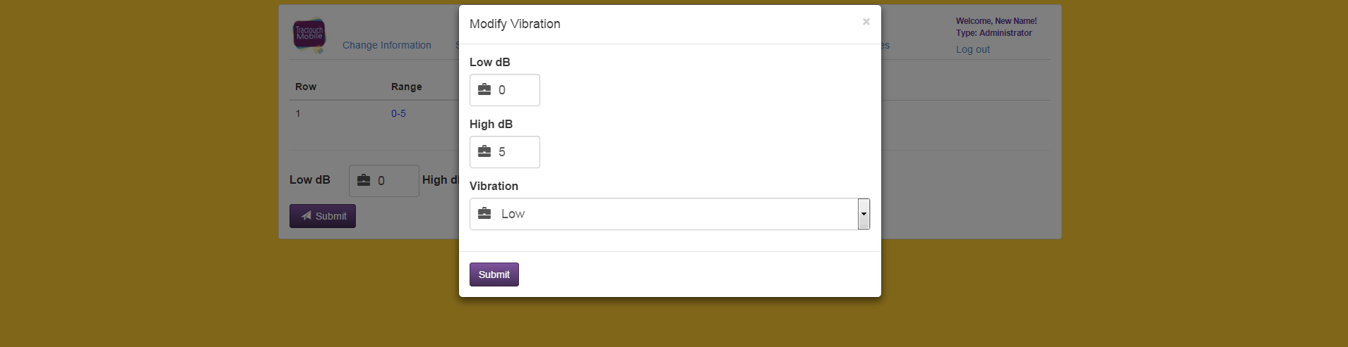
Modify all fields that need to be changed, and click submit.

Check SPL Values

Click on “Check SPL Values” in the navigation bar. The user will be displayed with a screen similar to this.


In this situation, no user under this account has recorded an SPL value, therefore no information is displayed.

Create User

The user clicks on “Create User” on the navigation bar. Following this screen is displayed.


Click on add user in order to show the following pop up dialog.

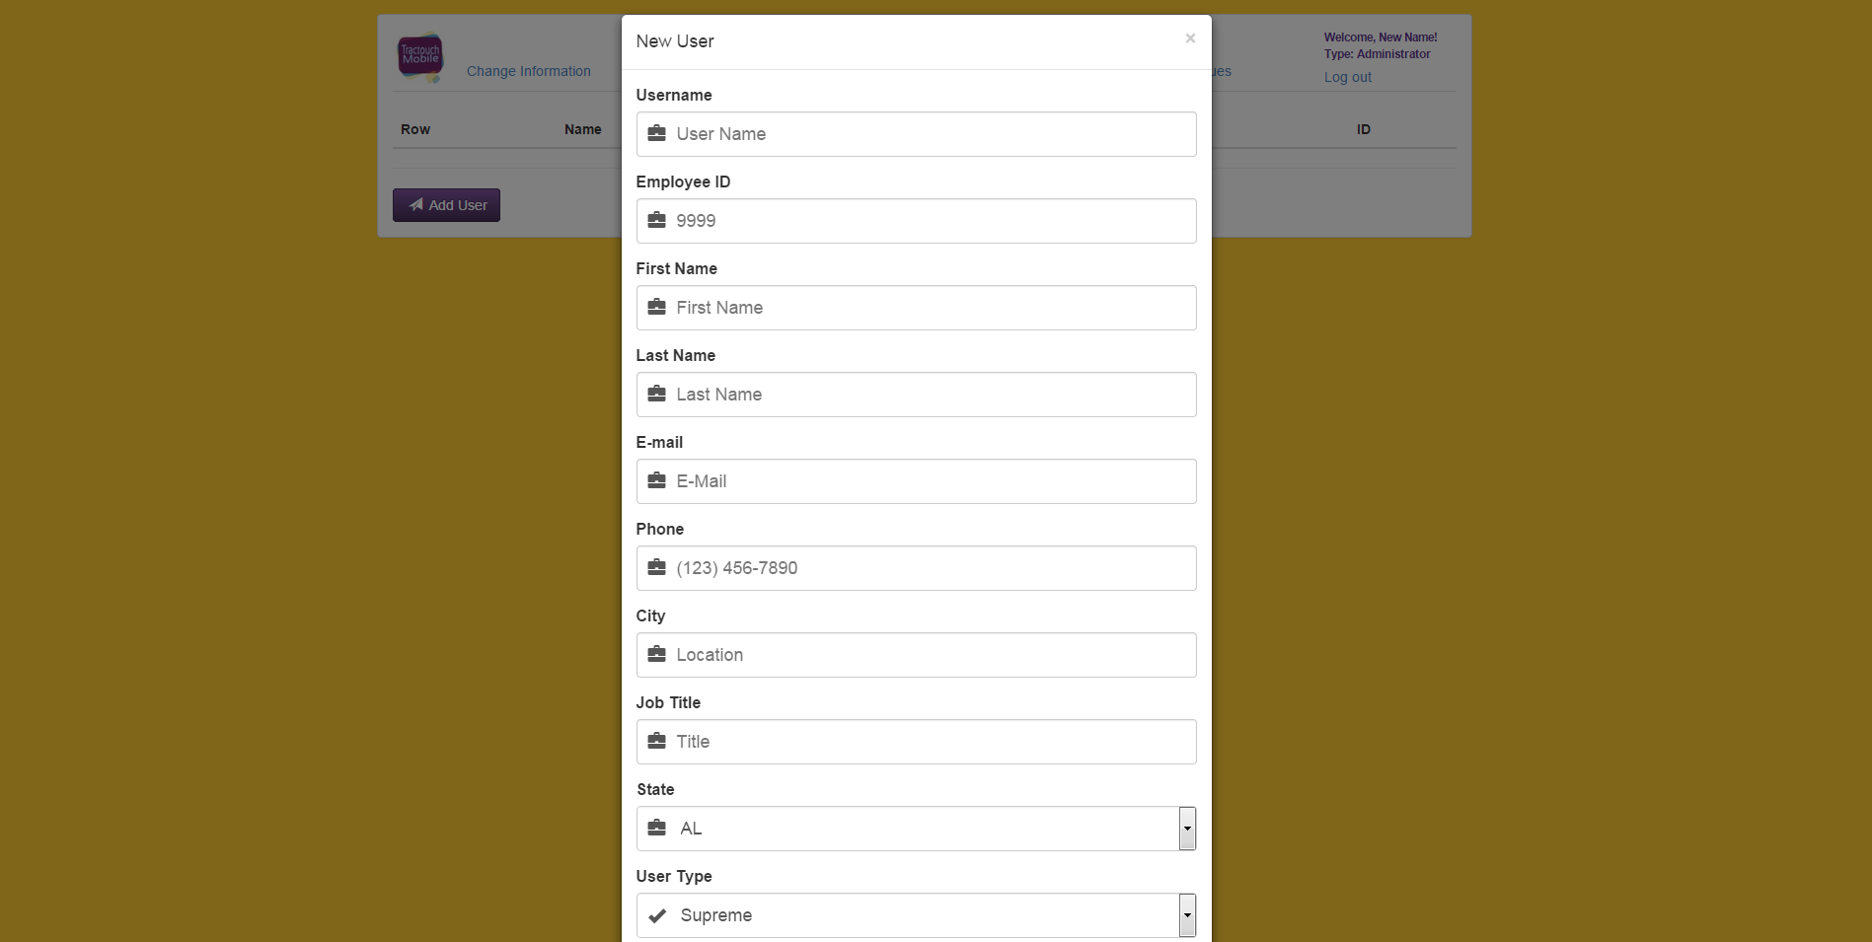
Completely fill the form (make sure the e-mail is correct given that it's with the new password), and click submit.

Delete User

Click on the blue label to display the actions available for this user. Click “Delete”.


Modify User info

Click on the blue label to display the actions available for this user. Click “Modify Info”.

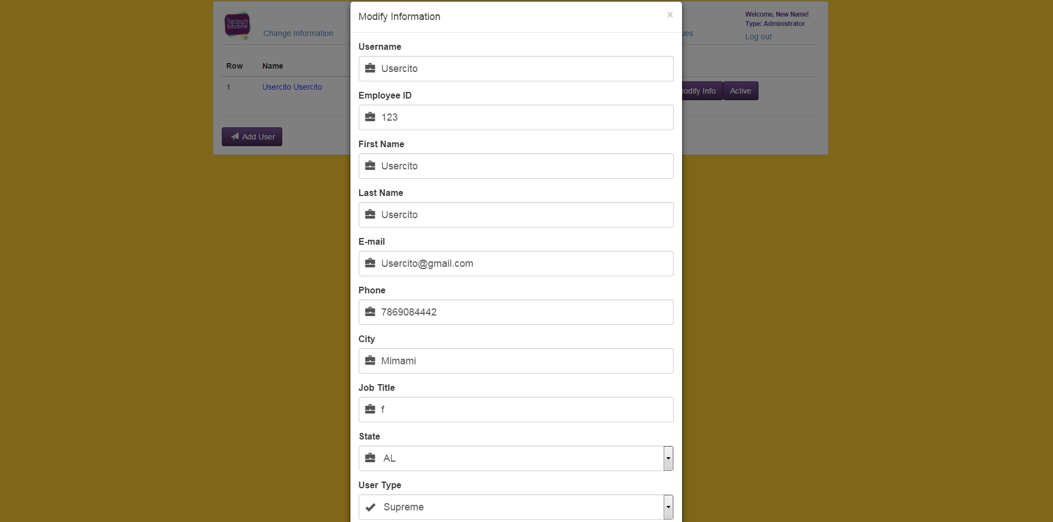
Modify all information that need to be changed and click submit.

Toggle Active Status

Click on the blue label to display all actions available for this user. Click on Inactive/Active (in this screen shot the user is inactive and therefore inactive is shown, had the user been active, active would have been shown).


